

GROUNDS MAINTENANCE CONTRACT “B”

PILNING & SEVERN BEACH PLAYING FIELDS

2025 – 2028

Index

Invitation to Tender 3
Section A
Standard Conditions of Contract 4
Additional Erection/Installation 4
Duration of the Contract 4
Extent of Work 4
Health and Safety 5
Insurance 5
Notes to Tenderers 5
Officer 4
Payment to Contractor 4
Site Details 4
Termination of Contract 5
Workmanship and Equipment 4
Section B
Specification of works 6
Boundaries 6
Bulbs and corms 7
Damage to surfaces 7
Grass Clippings 6
Growth regulators 6
Health & Safety 6
Obstructions 7
Poor weather 7
Prior Inspection 6
Soft vegetation 6
Standard of cut 7
Surface damage 6
Tennis Court 7
Training 6
Use of machinery 6
Section C
Schedule of Works 8
Pilning Playing Field 8
Pilning Tennis Court 8
Severn Beach Playing Field 8
Section D
Site Plans 9
Pilning Playing Field and Tennis Court 9
Severn Beach Playing Field 10
Section E
Form of Tender 10
Section F
Questionnaire 12

Invitation to Tender
- Pilning & Severn Beach Parish Council ("the Council") hereby invites tenders for the carrying out of the Service of Grass Cutting in accordance with this Contract document:-
Section A - Standard Conditions of Contract
Section B - Specification of Works
Section C - Schedule of Works
Section D - Site Plans
Section E - Form of Tender
Section F - Questionnaire

- Prospective Contractors should ensure that they are completely familiar with the nature and extent of the obligations to be accepted by them if their tender is accepted.
- Any queries regarding the interpretation of any part of the Contract documents should be addressed to the Parish Clerk by no later than one week before the closing date.
- The tender shall be submitted on the Form of Tender attached at Section E
- Prospective Contractors should note that the Council is not bound to accept the lowest, or any tender. The Council’s decision is final and no correspondence will be entered into on the reasons why a tender has been rejected.
- The successful tender together with the Council's written acceptance shall form a binding agreement in the terms of the Contract documents
  - If having examined the tender documents you wish to submit a tender you should: - Fully complete and return the following documents:
    - Section E - Form of Tender
    - Section F - Questionnaire
  - Return tenders and all related documentation to: -
Pilning & Severn Beach Parish Council
6 Vicarage Road, Pilning South Gloucestershire. BS35 4LN by 5pm on Monday 25th November 2024.
  - Please note that the package containing the tender must be clearly marked “Tender for grounds maintenance” on the outside. This is in the interests of fairness, to ensure that all tenders are opened at the same time.

Tenders received late will not be considered.

Section A - Standard Conditions of Contract

Officer
The Officer will be the Parish Clerk.

Extent of Work
Generally, the work will comprise of the cutting of grass and selective weed control where specified on land within the parish of Pilning & Severn Beach Parish Council.
To include
- strimming around play equipment,
- outside furniture,
- trees, bushes, fences, hedges
- all other authorised site fixtures and fittings.
- To include grass removal from all play safety surfaces and footpaths by sweeping or blower.
- Works also include periodic works to trees and hedges across various sites.

Site Details
The sites are situated throughout Pilning & Severn Beach Parish and are identified on the plans enclosed under Section D - Site Plans.
Before tendering the Contractor is advised, at their own discretion, to visit the sites to satisfy themselves as to the full extent of the Contract Specification. No claims arising from failure to do so will be accepted.

Workmanship and Equipment
The workmanship must be of the highest standard and shall conform to all relevant British standards, Specifications and Codes of Practice.

Additional Erection/Installation
The Council could add additional outside fixtures and fittings during the period of the Contract (e.g., play equipment) and no application from the Contractor to adjust the Contract price will be considered.

Duration of the Contract
The duration of the Contract will be three years from 1st April 2022, with the final decision on the duration of the Contract to be made by the Council after the tenders have been received. Tenders are to be priced on an annual basis. There will be no opportunity to alter the rates tendered during the term.

Payment to Contractor
The full contract sum shall be paid in equal monthly instalments throughout the year, on receipt of a monthly invoice from the Contractor.

Termination of Contract
Either party may, without reason, terminate the Contract, in writing, giving three months’ notice.

Insurance
The Contractor is required to have a minimum of £10,000,000 public liability insurance. A current Certificate of Insurance to this effect must be produced to the Parish Clerk prior to commencement of the Contract. The Contractor shall indemnify the Council against any claim or proceedings for any injury or damage to any property or persons or animals because of negligence, poor workmanship or failure to notify the Council of any action likely to cause injury or damage to a third party.

Health and Safety
The Contractor shall accept full responsibility for compliance with the Health and Safety at Work Act and all other Acts and Regulations in respect of the work comprised in this Contract.

Notes to Tenderers
- Attention is drawn to the Form of Tender and Standard Conditions of Contract. These documents must be read in conjunction with the Specification of works, Plans and Schedule of Works. Contractors are advised to carefully read all documentation.
- The prices to be included in the Form of Tender are to be the full inclusive value of the work described, including all profit, costs and expenses, and all general risks, liabilities and obligations.
- A price shall be inserted against each item on the Form of Tender.
- No alteration to the text of the Form of Tender is to be made by the Contractor tendering. Should any alteration, amendment, note or addition be made, the same will not be recognised and the reading of the printed Schedule will be adhered to.
- Weed killing chemicals must only be applied where specified and must be applied by certificated staff. Evidence of certification must be provided to the Council.
- A regular inspection will be carried out by the Council throughout the period of the Contract to ensure the work is completed in accordance with the Specification of works.
- Invoices presented for payment must include a schedule of the works completed in that month including the dates of the work.
- Contractors are asked to contact the Parish Clerk if any clarification is required.

Section B - Specification of works

Prior Inspection
- Prior to cutting any area, the Contractor will ensure that it is free of significantly large stones, paper, tins, bottles and other debris.
- The Contractor will also inspect each site for areas of ground sinkage/potholes and areas of potential hazard and will inform the Council immediately of any specific hazards.

Use of machinery
The Contractor shall during the period of the Contract, ensure that all machines engaged in grass cutting operations are sharp and properly set, to produce a true and even cut. Any damage or areas of grass not cut to the approval of the Council from such lack of maintenance will be made good by the Contractor at their own expense and to the satisfaction of the Council.

Health & Safety
The Contractor shall during the period of the Contract ensure that machines are properly guarded and maintained to present no danger to the operator, surrounding structures, vehicles or any person in the vicinity of operations. The Contractor will provide their staff with all safety equipment, (boots, reflective vests, ear defenders etc.), and will ensure that staff always use these when they are engaged in work for the Council.
The works shall be carried out in accordance with the Health and Safety at Work Act and other legislation relating to work being undertaken in Public Areas

Training
All persons operating grass cutting machinery must be satisfactorily trained, and the Council reserves the right to ask the Contractor to provide adequate proof that their operators are well trained, conversant with Health and Safety legislation and competent in their operating methods.

Growth regulators
During the period of the Contract no growth regulators of any form will be applied to any area of turf without the Council sanctioning such an operation in writing, in advance.

Surface damage
All grass will be cut cleanly and evenly and without damaging the existing surface.

Grass Clippings
The Contractor will complete one area of grass cutting before moving onto the next, and immediately after cutting a scheduled area, the Contractor will ensure that all grass clippings and other arisings are cleared from all paved areas, playground equipment safety surfaces, memorial stones, paths and public footpaths, etc. by sweeping or using a blower.

Soft vegetation
Soft vegetative growth, such as clover will be deemed to be part of the Contract where it falls within large areas of grass.

Boundaries
Mowing will take place on the full area of grass at the site, up to the paving, fencing obstacles and any other boundaries.

Standard of cut
Areas not cut to the satisfaction of the Council will be re-cut by the Contractor at the Contractor’s own expense.
Inspections are carried out either by the Clerk or a member of the Parish Council each month.

Poor weather
In very wet conditions all operations involving grass cutting shall cease until conditions allow operations to recommence without damaging the surface levels and contours of the ground or grass cutting “divots” from the machine rollers or cutters.

Damage to surfaces
Should the Contractor cause damage to the surface or levels of the ground, or create divots during grass cutting operations, the Contractor will at their own expense reinstate such damage forthwith to the satisfaction of the Council.

Obstructions
  - Mowing will be carried out as close as possible to fixed obstructions. Moveable obstructions can be removed to facilitate cutting and replaced before the Contractor leaves the site.
  - Mowing around obstructions including seats, trees, fence lines, posts, and the like, and in the proximity of margins, will be undertaken using methods, tools and machines as appropriate. The cutting of such areas will be undertaken within 24 hours of the main site being mowed and will be deemed to be included in the Contractor's rate for each location.
  - Extra care must be taken when strimming up to the wooden structures listed below
    - Fort at Pilning Playing Field
    - Play trail at Severn Beach Playing Field
    - Circular swing set at Severn Beach Playing Field

Bulbs and corms
In areas that contain bulbs or corms, the Contractor will ensure that the emergent bulbs are not cut. These areas will not be cut again until four weeks after flowering.

Tennis Court
Spray court edges for weeds two times per year using chemicals safe for use in public areas and strim around internal side of fence: remove any arisings.

Section C - Schedule of Works

All the below listed cuts are subject to weather conditions.

Pilning Playing Field, Cross Hands Road, Pilning

 | Jan | Feb | Mar | Apr | May | Jun | July | Aug | Sep | Oct | Nov | Dec
 | None | None | 2 Cuts | Weekly | Weekly | Weekly | Weekly | Weekly | Weekly | 2 Cuts | 2 Cuts | None
2025 |  |  | (2) | 4 | 5 | 4 | 4 | 5 | 4 | 2 | 2
2026 |  |  | 2 | 4 | 5 | 4 | 5 | 4 | 4 | 2 | 2
2027 |  |  | 2 | 4 | 4 | 4 | 5 | 4 | 4 | 2 | 2
2028 |  |  | 2

Severn Beach Playing Field, Ableton Lane, Severn Beach

 | Jan | Feb | Mar | Apr | May | Jun | July | Aug | Sep | Oct | Nov | Dec
 | None | None | 2 Cuts | Weekly | Weekly | Weekly | Weekly | Weekly | Weekly | 2 Cuts | 2 Cuts | None
2025 |  |  | (2) | 4 | 5 | 4 | 4 | 5 | 4 | 2 | 2
2026 |  |  | 2 | 4 | 5 | 4 | 5 | 4 | 4 | 2 | 2
2027 |  |  | 2 | 4 | 4 | 4 | 5 | 4 | 4 | 2 | 2
2028 |  |  | 2

⁋ Based on the number of Fridays in a month.
Pilning Tennis Court, Cross Hands Road, Pilning

Jan | Feb | Mar | Apr | May | Jun | July | Aug | Sept | Oct | Nov | Dec
None | None | None | Weedkiller | 1 cut | 1 cut | Weedkiller | 1 cut | 1 cut | None | None | None
0 | 0 | 0 | 1 | 1 | 1 | 1 | 1 | 1 | 0 | 0 | 0

Section D - Site Plans

Pilning Playing Field and Tennis Court
Cross Hands Road Pilning
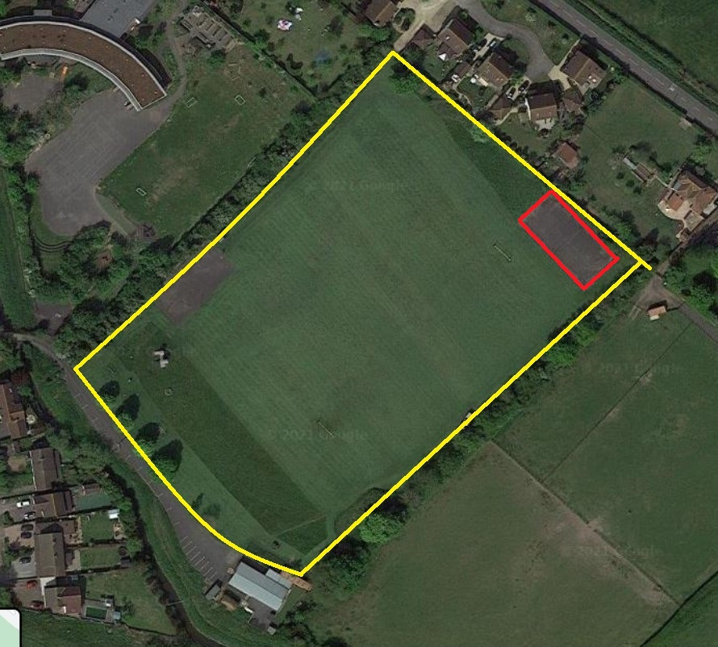

Tennis Court is shown edged in red

Severn Beach Playing Field
Ableton Lane, Severn Beach

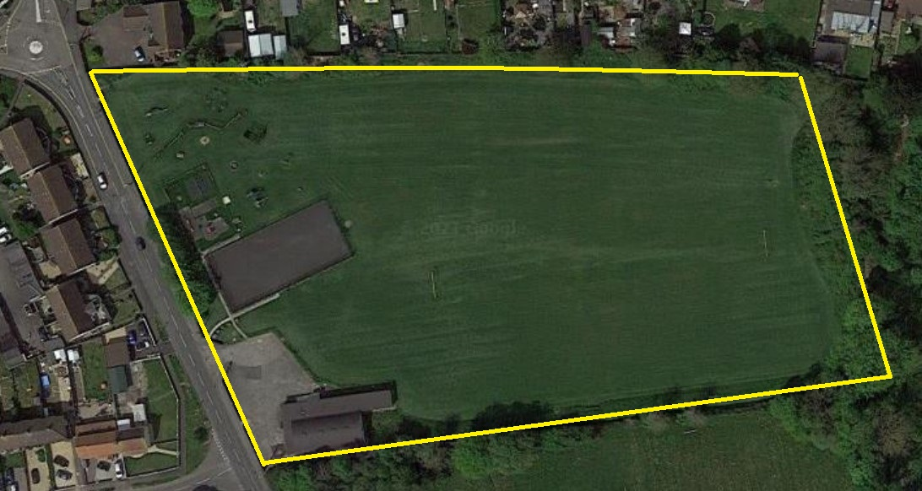

Section E - Form of Tender

 | 2025/26 | 2026/27 | 2027/28
Pilning Playing Field
Grounds maintenance thirty-two visits in every twelve months. As per section B and C
Annual Cost
Severn Beach Playing Field
Grounds maintenance thirty-two visits in every twelve months. As per section B and C
Annual Cost
TOTAL CONTRACT COST

I/We agree to complete the work in accordance with the Invitation to Tender, Standard Contract Terms, Specification of works, Schedule of Works and location plans.
I/We understand that Pilning & Severn Beach Parish Council is not bound to accept the lowest or any Tender and that the Council will not be responsible for any expense incurred in preparing this Tender.
I/We certify that the amount of the Tender has not been calculated by agreement or arrangement with any other person, firm or company and that the amount of the Tender has not been communicated to any person and will not be communicated to any person until after the closing date for the submission of Tenders.

Signed

Name (printed)

Position

Date

Address

Telephone Contact

Copies of Pilning & Severn Beach Parish Council Standing Orders can be found on our website https://www.psbpc.co.uk/policies or copies can be obtained from the Clerk.

Section F - Questionnaire

Details relating to the prospective Tenderer
Name

Address

Telephone Number

Email address

Contact name

Position in the company

Nature of the business

Is this a subsidiary company? YES / NO
If yes please give details

Date of Business formation / /
Please state number of grounds maintenance employees

Please state which branch the Contract will be serviced from

Please give any other details, which you feel may be relevant, for example, similar Contracts in the area or for similar authorities, etc

Signed

Position

Date

Health and Safety at Work Act 1974
To ensure compliance with the agreement and secure payment of the monthly invoice.
In accordance with Pilning & Severn Beach Parish Council Standing order 18c

